 Bed Bath & Beyond

**Manual Infra Document**

***Manuel Infra Document***



Document Control

| **Revision** | Date | Updated By | Description |
| --- | --- | --- | --- |
| 1 |  | Mohit Kumar |  |

Contributors

| Name | Email ID | Work Phone |
| --- | --- | --- |
|  |  |  |
|  |  |  |
|  |  |  |

Reviewers

| Name | Email ID | Work Phone |
| --- | --- | --- |
| Sunil Kumar | [skumar134@sapient.com](mailto:skumar134@sapient.com) |  |

Primary Contacts

|  |  |  |  |  |
| --- | --- | --- | --- | --- |
| App | Contact Name | Job Title | E-Mail ID | Work Phone |
|  |  |  |  |  |
|  |  |  |  |  |

*Note: To be contacted in the given order.*

**Table of Contents**

1. Introduction 4

2. URL Rewrites 4

3. BCC production and staging site Configurations 4

4. Jar Upgadation 4

# Introduction

This document contains manual steps E.g. Url re-write rules executed by Infra team which need to be applied on higher environments as well and BCC configuration for simplified registry repository mapping configuration that needs to be done on all higher environments by Infra team and steps to insert Bazaarvoice seo jar on maven mirror site in Bath & Beyond’s PSI8 release.

1. Apache Redirect Changes(URL Rewrite Rules)

|  |  |  |
| --- | --- | --- |
| S.No | Rewrite file | Desciption |
| 1. | /store/browse/prime_gift_registry_data.jsp | Re-write rule to allow call of the mentioned JSP from HTTPS protocol. This JSP is not used for serving content. |
| 2. | store/_includes/modals/dsl_alternate_modal.jsp?bbbModalDialog=true | Such that it serves HTTP response for HTTP request and HTTPS response for HTTPS request. |
| 3. | **/store/includes/vdc_learn_more.jsp** | Re-write rule to allow call of the mentioned JSP from HTTPS/HTTP protocol. |
| 4. | [/store/browse/dynamicStaticContent.jsp?pageName=ItemShippedDirectlyFromVendor&isVdcSku=true&skuId=18523353&bbbModalDialog=true](http://bedbathbeyond-24.sapient.com/store/browse/dynamicStaticContent.jsp?pageName=ItemShippedDirectlyFromVendor&isVdcSku=true&skuId=18523353&bbbModalDialog=true) | Such that it serves HTTP response for HTTP request and HTTPS response for HTTPS request. |
| 5. | */store/_includes/modals/poBoxModal.jsp* | *RewriteCond %{REQUEST_URI} !^/store/_includes/modals/poBoxModal.jsp [NC]* |
| 6. | */store/selfservice/frags/find_your_college_json.jsp* | https to http:   RewriteCond %{REQUEST_URI} !^/store/selfservice/frags/find_your_college_json.jsp [NC] |
| 7. | /store/cart/static/shipping_restrictions_applied.jsp | Https to Http:  RewriteCond %{REQUEST_URI} !^/store/cart/static/shipping_restrictions_applied.jsp [NC] |
| 8 | |  |  | | --- | --- | |  | /store/couponWallet/walletLanding.jsp | | Re-write rule to allow call of the mentioned JSP from HTTPS/HTTP protocol. |
| 9 | /store/edw/edw_data.jsp | Add to below entry in rewrite_https-http.conf  RewriteCond %{REQUEST_URI} !^/store/edw/edw_data.jsp |
|  |  |  |

## BCC Production and Staging site configuration:

## We need to have SimplifyRegistry repository mapped for both Staging, and Production servers in BCC.

## Production:

## Source: /com/bbb/simplifyRegistry/repository/SimplifyRegistry

## Destination: /com/bbb/simplifyRegistry/repository/SimplifyRegistry_production

## Source: /com/bbb/edwProfileData/edwSiteSpectData/repository/edwSiteSpectData

Destination: /com/bbb/edwProfileData/edwSiteSpectData/repository/edwSiteSpectData_production

## Staging:

## Source: /com/bbb/simplifyRegistry/repository/SimplifyRegistry

## Destination: /com/bbb/simplifyRegistry/repository/SimplifyRegistry_staging

## Source: /com/bbb/edwProfileData/edwSiteSpectData/repository/edwSiteSpectData

## Destination: /com/bbb/edwProfileData/edwSiteSpectData/repository/edwSiteSpectData_staging

## Please refer to the screenshot below for setting repository mappings for Production site; we need similar mapping for staging as well:

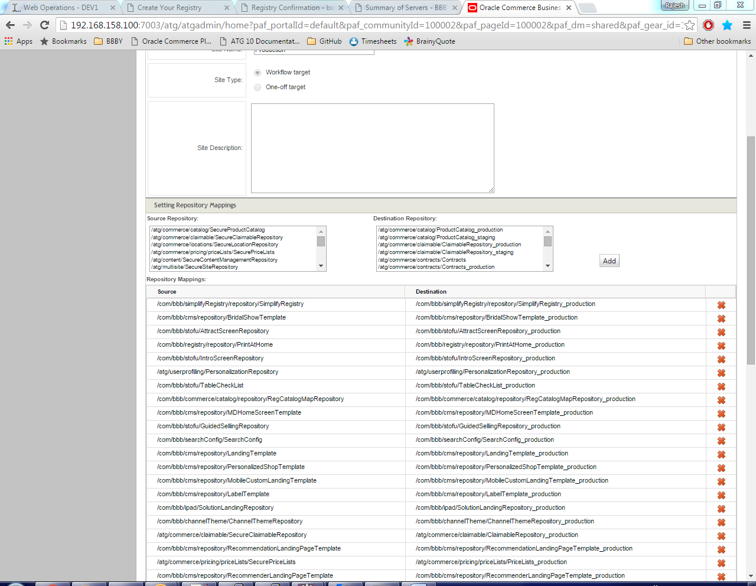

1. **Steps to insert Bazaarvoice seo jar on maven mirror site in Bath & Beyond’s PSI8 release**
   1. To set up Bazaarvoice jar on mirror site, unzip below zip file and place it at location com\bazaarvoice\bv-seo-sdk-jar-with-dependencies\3.1.1.
   2. As for example for mirror url <http://10.207.4.182:8080/nexus-2.1.2/content/groups/public/>

bazaarvoice jar should appear like <http://10.207.4.182:8080/nexus-2.1.2/content/groups/public/com/bazaarvoice/bv-seo-sdk-jar-with-dependencies/3.1.1/bv-seo-sdk-jar-with-dependencies-3.1.1.jar>

* 1. Mirror url is configured inside settings.xml file at location apache-maven-3.0.4\conf.



Please refer below document for BCC repository mapping.